Rolf presents new collection Spring | Summer 25
At Opti in Munich at the end of January, Rolf will be presenting the new spring | summer 2025 collection and will be joining Milan-based Mido in February for the second round of trade fair highlights. The collection will include new and sophisticated models from the Substance Collection, new bean eyewear for kids, sunglasses with stylish inlays from the Mount Collection and new products in wood and stone.
Fresh colors | Bold shapes
The spring | summer collection surprises with striking, graphic details, stylish inlays for sunglasses and an unexpected pop of color in keeping with the title _ see and be seen. The new models don't just help you see - they also make you look good!

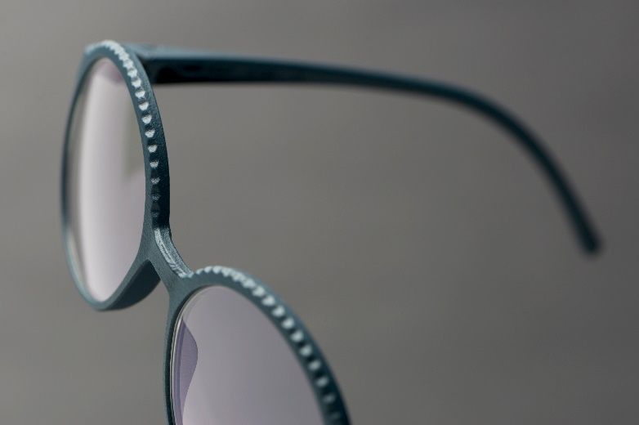 
RAIS | substance collection
The wave-shaped bevel above the eyes gives the model the right twist.
The perfect blend of delicate flow and striking personality.
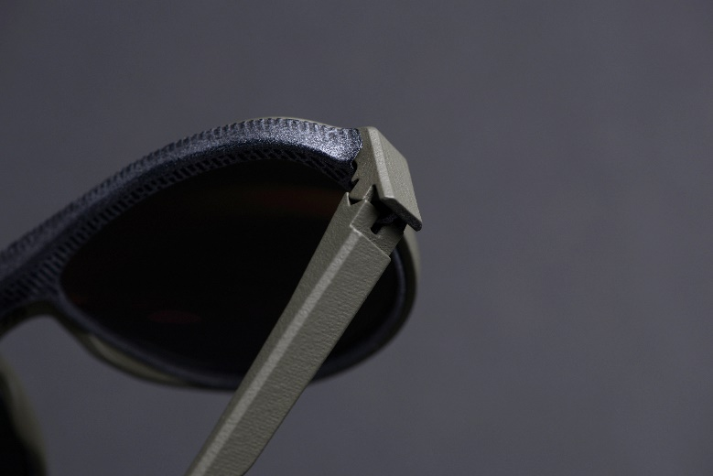
ARAR | substance mount sun
The bold frame with double bridge and the generous shape give ARAR its masculine character, which is guaranteed not to be overlooked.

